
Key Vocabulary
export | to send to another country to sell
Import | to bring from another country, especially as something to be sold
merchants | one who buys goods and sells them for a profit
prosperity | the state of being wealthy and successful
slavery | the owning of people by other people
human rights | rights regarded as inherently belonging to all human beings. Eg right to life, freedom, dignity
abolition | the act of doing away with or putting an end to
modernised | to make modern, bring up to date
transatlantic | going or reaching across the Atlantic Ocean

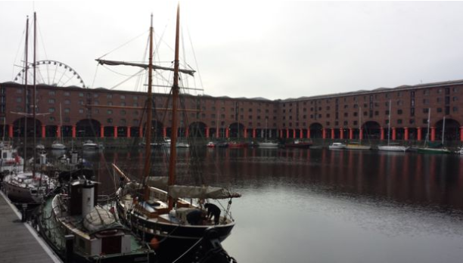
A History of Liverpool
History KNOWLEDGE ORGANISER

Substantive Knowledge
1190 - Liverpool was known as ‘Lieurpul’

1207 – Liverpool founded by King John

1715 – Liverpool's first official dock built

The ports were used to import goods such as cotton, sugar, tea, cocoa from other parts of the world.

The city of Liverpool became very wealthy from the trade the ports provided.

The Albert Dock is named after Prince Albert. He opened the dock in 1846

Between 1700 and 1807, ships from Liverpool made many transatlantic crossings transporting approximately 1.5 million enslaved Africans.

By 1792 Liverpool was firmly established as the leading slave port.

Some people such as William Roscoe campaigned for the abolition of slavery.

Some people opposed the abolition of slavery such as James Penny.

In May 1941, the Liverpool Blitz took place due to the significance of the docks.

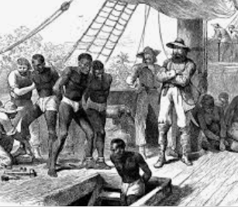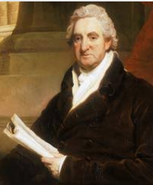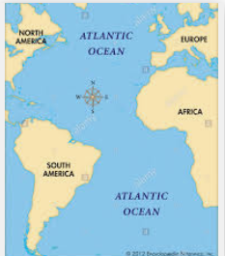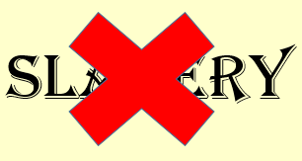

Year 4 Autumn Term

