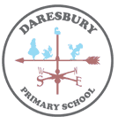
Substantive Knowledge
- Animals can be divided into two main groups: those that have backbones (vertebrates); and those that do not (invertebrates).
- Vertebrates can be divided into five small groups: fish; amphibians; reptiles; birds; and mammals. Each group has common characteristics.
- Invertebrates can be divided into a number of groups, including insects, spiders, snails and worms.
- A classification key uses yes/no questions to sort living things.
- If habitats change, this can cause a species to decrease or increase.
- Habitats can be damaged or destroyed by humans (e.g. deforestation), natural disasters or climate change.

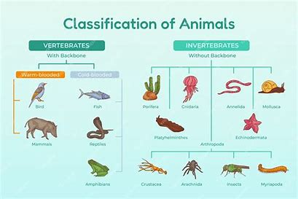
Key Vocabulary
vertebrates | An animal that has a backbone.
invertebrate | An animal that doesn’t have a backbone.
mammal | Mammals include humans and all other animals that are warm-blooded vertebrates (vertebrates have backbones) with hair. They feed their young with milk and have a more well-developed brain than other types of animals.
amphibian | Amphibians are cold-blooded vertebrates (vertebrates have backbones) that don't have scales. They live part of their lives in water and part on land.
reptiles | a vertebrate animal of a class that includes snakes, lizards, crocodiles, turtles, and tortoises. They are distinguished by having a dry scaly skin and typically laying soft-shelled eggs on land.
fish | a limbless cold-blooded vertebrate animal with gills and fins living wholly in water.
birds | warm-blooded egg-laying vertebrate animal distinguished by the possession of feathers, wings, a beak, and typically by being able to fly.
Classification key | Using yes/no questions to sort living things
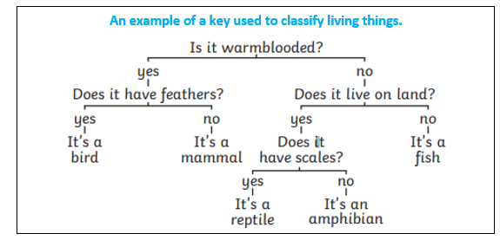

Classification of Living Things
Science KNOWLEDGE ORGANISER

Year 4 Autumn Term

