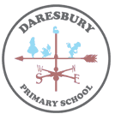
Key Vocabulary
Volcano | An opening in the earth's crust through which melted rock, ash, and gases are forced out.
Core | The centre part of any round, solid object. The centre of the earth is called its core.
Tectonic plates | One of the plate-like segments of the Earth's crust and upper mantle. The plates form the outer shell of the planet, and they are moving very slowly. Where the plates meet each other, their movement can cause or play a part in the eruption of volcanoes, the building of mountains, and the occurrence of earthquakes.
Mantle | The layer of the earth that lies between the crust and the core.
Crust | The outer layer of Earth
Magma | Hot, liquid matter beneath the earth's surface that cools to form igneous rock. Magma that reaches the earth's surface, as when a volcano erupts, is called lava.
Crater | A hollow area shaped like the inside of a bowl. The mouth of a volcano is a crater.
Eruption | The act or process of erupting (bursting).
Earthquake | A shaking or other movement of part of the earth's surface. It is caused by movement deep within the earth.
Epicentre | The point on the earth's surface directly above the central source of an earthquake.

Year 4 Spring Term
Substantive Knowledge
- The earth is made up of different layers; crust; mantle; outer core and inner core.

- The earth is covered in tectonic plates which are constantly moving.

- The point on the Earth’s surface at the centre of an Earthquake is called the epicentre.

- Earthquakes occur when tension is released from inside the crust.

- An earthquake is the shaking and vibration of the Earth's crust due to movement of the Earth's plates (plate tectonics).

- On land, volcanoes form when one tectonic plate moves under another.

- A volcano connects magma from the earth’s crust to the earth’s surface.

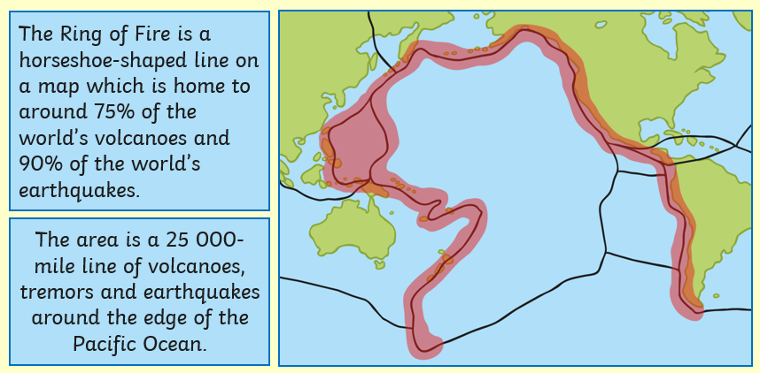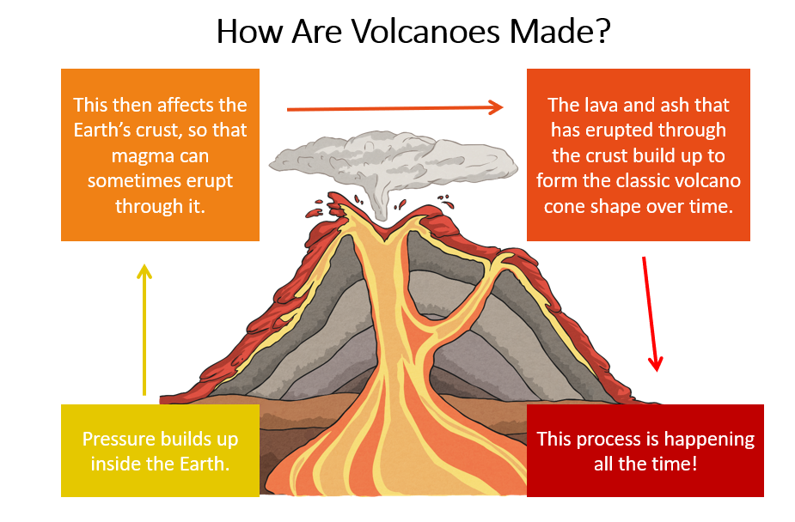
Volcanoes and earthquakes
Geography KNOWLEDGE ORGANISER

