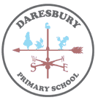
Bronze and Iron Age hillforts like the one below were built on top of hills so that it was difficult for enemies to invade. This was because they would be spotted by lookouts very easily.
Substantive Knowledge
- The Bronze Age in Britain lasted from about 3000BC – 800BC.
- Bronze was used as a new metal to make tools and weapons.
- Farming advanced with bronze tools to plough fields and weapons improved along with other advancements in daily life.
- The Iron age of the British Isles covers the period from 800BC to the Roman invasion in 43AD .
- During the Iron-age, daily life was based around farming and iron tools/weapons/household items made life easier.
- Celtic tribes fought for control, resources and territory and used hillforts for protection.
- Druids were religious leaders of the Celtic religion and were the legal authority throughout communities in Bronze Age Britain.

What else was happening in World History at this time?
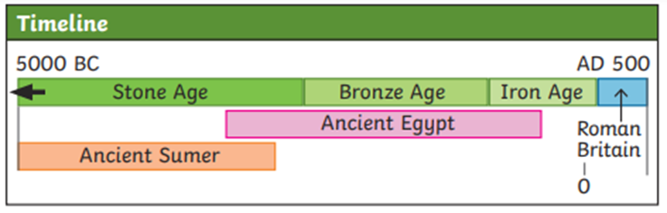

Key Vocabulary
symbols | an object or symbol that represents something
advanced | beyond the level of others
ceremony | a formal act or series of acts done in a particular way to honour a special occasion
druid | a member of a priestly order in ancient Celtic lands
tribe | a group of people, families or villages that share the same language, social customs and ancestors
Celts | a member of any Indo-European peoples whose language is Celtic.
hillfort | a protected group of buildings or settlement on a hill
territory | an area of land
intellectual | very smart or intelligent
legal | to do with law
authority | the right or power to give orders, make decisions or control people.

Bronze and Iron
Bronze is an alloy (a mix of metals) made from copper and tin. Iron occurs naturally in the earth. They can both be melted and shaped into weapons and tools.

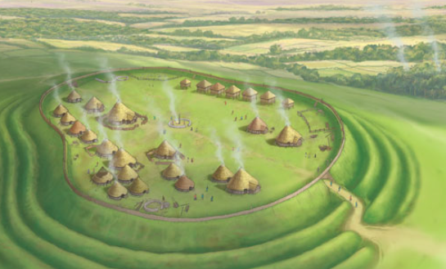
Year 3 Summer Term
The Bronze Age to Iron Age
HISTORY KNOWLEDGE ORGANISER

