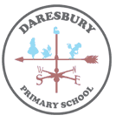
Key Vocabulary
rural | to do with the countryside
urban | to do with a town or city
countryside | a place located away from towns and cities which is used for farming or left in its natural condition
amenities | a useful or pleasant facility or service
county | - an area or piece of land controlled by a local government
trade | the buying and selling of good and services
OS Symbols | easily understood pictures on a map
OS Maps | - Ordnance Survey map

Substantive Knowledge
- The UK has diverse land use; including rural and urban areas.
- The five counties of the Northwest are: Merseyside, Lancashire, Greater Manchester, Cheshire and Cumbria.
- OS maps use symbols to identify locations. The key can be used to read them.
- Rural and urban areas of the UK are connected by roads and rail.
- Trade links are made between rural and urban areas of the UK.
- The compass has 8 points.

Year 3 Summer Term 2
Urban and Rural UK
GEOGRAPHY KNOWLEDGE ORGANISER

Urban and Rural UK
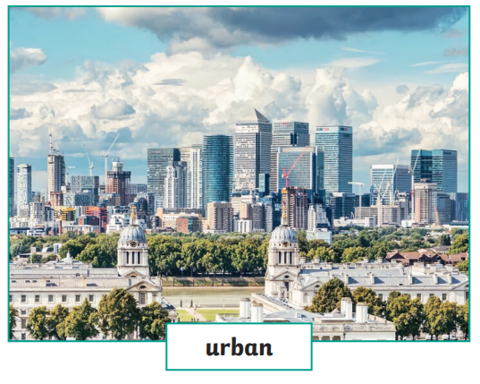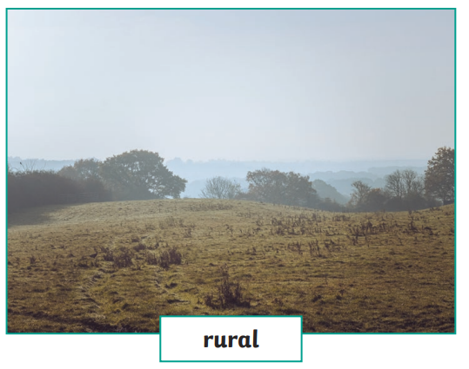

Isaac Newton is thought to have developed the theory of gravity after an apple fell to the ground from a tree.

Weight is how strongly gravity is pulling an object down. It is measured in newtons (N).

The eight points of the compass.
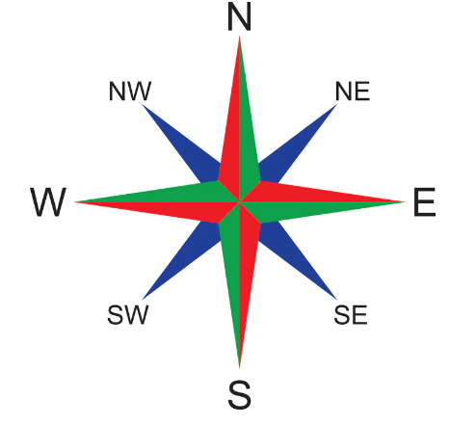
Urban areas have lots of buildings, shops, and factories. People who live there often work in offices, schools, stores or factories. There are often more cultural and recreational opportunities like theatres, cinemas, museums and parks. In contrast, rural areas tend to be more isolated and less accessible to basic services and amenities. They are often known for their open spaces and natural beauty.

