
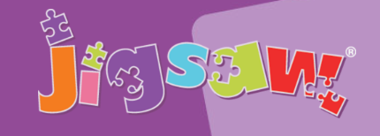

Substantive Knowledge
- I understand how everyone has the right to learn.
- I understand what it means to have rights and responsibilities.
- I understand that choices can influence rewards and consequences.
- I know how to face new challenges positively.
- I understand how democracy and having a voice benefits the school community.
- I know how to contribute towards the democratic process.
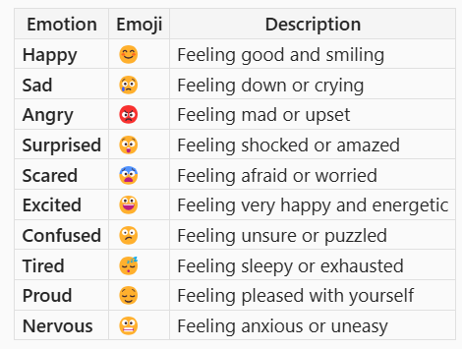

Year 5 Autumn 1
Key Vocabulary
citizen | a person who is a member of a country either because of being born there or being declared a member by law.
collaboration | a cooperative effort by which people or organizations work together to accomplish a common project or mission.
Collective decision | A choice or decision that is made by a group of people together, rather than just one person. Everyone shares their ideas, talks about them, and then the group agrees on what to do.
empathise | to share or identify with the feelings of another; feel empathy.
persecution | the act of continually treating others in a cruel way because of race, religion, politics, or some other difference from oneself or from the majority within a society; or the condition of being treated in this way
conflict | An answer to a problem or question.
asylum | a place that offers safety.

Being Me in My World
.
PSHE KNOWLEDGE ORGANISER

